|  |
| --- |
| Group 4 IST 707 |
| Mushroom Edibility Classification |
| *Poisonous or Edible?* |

|  |
| --- |
| Jonathan Xiong, Yu Sheng Lu, Joseph R Maugeri  9-20-2022 |

**Introduction**

*Contextual Background: History of Mushrooms*

The “Natural World” is a global term used to describe all components of the ecosystems on the planet. This could include bodies of water, populations of creatures, the inside of your stomach, or even the ground you walk on. Some might think the natural world is the antecedent to the manmade world, but this is simply not true. Ecosystems exist all over the planet, some arising completely independently of others. The unique nature in which their components comingle to shape a living system combined with evolution is what is responsible for the diversity of ecosystems present in the world. The only real reason there is a “Natural World”, is because there is now a describable manmade world. While it was not always this way, humankind has developed a heavy influence in shaping ecosystems over a relatively short span of time. As a result of our influence, many species of organisms, and many instances of ecosystems have been either reshaped, or destroyed. The retention of generational knowledge has allowed humans to manipulate the environment, and it is only recently that true impacts on the globe are being understood. This understanding has occurred over long periods of time in which humanity has effectively retained skills to utilize various ecosystems for life support. Across all the evidence of ancient peoples discovered through archaeology, there have been findings that suggest one class of organisms have been revered by humans in a particular way for a very long time.

Mushrooms have been discovered in the fossil record since before sharks, however they are incredibly rare due to their short growth patterns. The oldest extant mushroom is shown below, is dated at 115 “b.y.a” (billion years ago). (Heads S.W. et. Al. 2017)

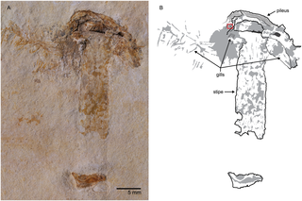

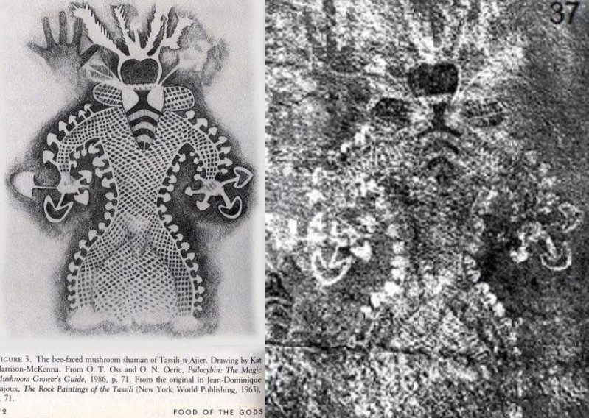This specimen was found in a “Lagerstätten”, a particularly rich fossil deposit, located in the Chapado do Araripe limestone formation, in Ceará, Brazil. This is some of the only evidence of mushrooms that dates them as far back as the Cretaceous period. However, many of the same features of modern mushrooms are still present. By the time the human species *(homo sapiens)* genetically replaced Neanderthals around 40,000 years ago, mushrooms had already covered and diversified over much of the globe. We know that these early humans co-existed with these organisms since the before written history. Through the study of human selection and utilization of mushrooms (Ethnomycology), many unique origins of the culture surrounding mushrooms have been suggested. Several Ancient cave paintings from across the globe depict the earliest examples of evidence of humans’ interactions with mushrooms. Modern interpretations often infer a ritualistic aspect is being shown in the paintings. The first image are from the *Pegtymel Petrogylphs*, Dating to 1. C.E. in Siberia, from a tribe of ancient whale hunters. We know that highly diversified mushrooms were depicted as “common tools” of shamans, for medicinal and even spiritual aspects of early cultures. (Skarbo S.2014) Many mushrooms found in the ancient whaler’s area contained psilocybin*,* which has a chemical effect on the human brain that causes action potentials to fire differently. This commonly produces a euphoria effect, and the sensation of stimuli being perceived through senses more vividly. The second image depicts a painting from Tassili n’Ajjer in Algeria, which is a plateau in the Saharan desert. A reconstruction of the original image is shown left. This and others at the site are between 9,000 and 7,000 years old and are thought to be the earliest depiction of “psychedelic” usage of mushrooms in human culture.

This ritualistic reverence of mushrooms continued to proliferate through many cultures as civilization developed. These organisms have been called “Food of The Gods”, by the Romans (Valverde, M. E., 2015), and revered highly by the Chinese since 600 B.C.E. (FoodPrint). Famous Roman philosopher Galen wrote in his notebook describing the Chinese cultivating what where likely shitake mushrooms. The Egyptians believed that mushrooms grew through magic, as some were able to double in size in a span of 24 hours. Even today, ethnomycologists are studying various ethnic groups in Africa, in attempts to document their habits and practices in mushroom foraging. Sitotaw R. 2020 examined several of these ethnic groups in Ethiopia, which found several examples of mushrooms used as high-quality food, medicinal cures, and divination rituals.

Again, since there is not much documentation on the rituals, or even the diversity of mushrooms in the country, which reports several unique examples of mushrooms found nowhere else. As the contemporary world continues to replace the traditional one, it’s important that traditional knowledge is not lost through future scientific endeavors. Mushrooms are arguably one of the oldest, and most widespread components of human culture. To this day there is still much the scientific community does not know about mushrooms due to the nature in which many species are diversified in terms of their genetics. Many species resemble those of other species, and most mushrooms are unable to be classified on visual appearance alone. The traditional knowledge that ethnic groups have allows them to find mushrooms reliably. Finding the correct mushroom in many cases is very significant, as poisonous species often appear identical to non-poisonous members. Given there is not much information on species on the scientific record, often scientists will utilize ethnic groups knowledge to gain understanding of mushrooms in various habitats. In more developed areas, some mushrooms have been repeatedly recorded to a point of feature level identification. Having that level of information in developing areas could inspire reverence for traditional ways, and help provide an understanding of how to protect the environments & cultures that mushrooms are found in.

*Describing Mushrooms as “Equally Diverse”*

Within that are mushrooms which have equally diverse variation amongst themselves. Extensive vocabulary is needed to effectively describe the patterns of features that may occur across species. Additionally, Mushrooms will exhibit a wide variety of features in their own species that can make classification difficult to an untrained individual. Even with decently accurate feature identification, it is very difficult to accurately classify mushrooms due to overlap in morphology between species that are poisonous with the species that are edible. Often, correct identification requires an expert evaluation of the complex features that are observed with the naked eye. Yet still, most mushroom specimens found cannot be definitively classified due to the morphological overlaps present. Using microscopic tools with spore printing techniques is the most accurate method for identifying specimens. Granted, spore prints are only a glance and the physical attributes of the reproductive parts of a mushroom and can be similar across genetically distant species.

*General Mushroom Features*

While there are many examples of outliers in the Fungi kingdom, it can be generally said that the archetype of a “mushroom” is identifiable by a few key traits. Those would be a cap, (pileus) which is the top of the mushroom. It can be convex, or concaved, even slightly amorphous. On the underside of the cap are what are gills (*lamella*), which may be pleated, solid, fibrous, or continuous. In most commonly recognizable mushrooms this is where the spores are produced and released from. Suspending the Cap is the stalk, (*stipe*) which may have rings, be ridged or smooth, and have a clean or spread root at the base. Those are the features at a general level for mushrooms, however as you dig into some of the more common morphological families there is much more diversity in them beyond what has been described. In the next section, two species from the *Agaricaceae* family are highlighted to expand further by example.

*Highlight of Family Agaricaceae Agaricus*

*Image taken from www.fungikingdom.net/fungi-photos/basidiomycota/*

The *Agaricaceae* family has over 20 genera within it. Some genera are widespread, and some are localized across different parts of the globe. Generally, this family of mushrooms enjoys wooded areas, and meadows. Some of the genera are poisonous and resemble those of genera that are not. Additionally, the *Agaricus* genera has some species that are commercially cultivated. The mushrooms depicted to the right are members of the *genus Agaricus abruptobublious.* These are at various stages of growth, with the cap reddening with age, ultimately becoming convex just before decaying. (Smith, D., n.d.)

*Highlight of Family Agaricaceae Lepiota*

*Image taken from www.inaturalist.com/taxa/194663-Lepiota-Magnispora*

Show right is genus *Lepiota,* species *magnispora*. Many of the genus are, (but not recommended) edible. Some of these are poisonous. In this case, the morphological differences are clear between the images of mushrooms shown, even as the move through varying stages of growth. The resemblance is not always as canny when you must consider some genera have hundreds of species within them, and a family can have many genera. Oftentimes, an educated guess can be made, but not proven without performing a spore printing technique. This is where the entire head of the mushroom is removed and placed gill down on pigmented paper. After the gills release spores, a print will show which may reveal the identity. However still, nothing short of viewing spore under a microscope and even sometimes DNA analysis are what many experienced mycologists will say when dealing with clades that present known increased misclassification danger. While these genera are well known, it is always possible that a new species is discovered. In that case, enough specimens must be separated out and have their DNA analyzed to finally prove an additional specimen should be defined.

**Analysis**

*The Mushroom Dataset*

Investigating the identification of mushrooms through features can be done if enough examples of a wide variety of features are present. There is much work to be done in the field to digitize and apply machine learning algorithms. Despite that, the inspirational dataset was obtained from a [Kaggle](https://www.kaggle.com/datasets/uciml/mushroom-classification?resource=download), which uses hypothetical samples corresponding to 23 species of “gilled” mushrooms of the *Agaricus* and *Lepiota* Families drawn from the “Audubon Society Field Guide to North American Mushrooms (1981). Each species is identified as “definitely edible”, “definitely poisonous”, “unknown edibility” and “not recommended”. The data also covers 22 features of the mushrooms, coded as single letters. There are no missing or N/A categories in the 8125 rows of the dataset. The Kaggle dataset author describes this dataset well:

*“Although this dataset was originally contributed to the UCI Machine Learning repository nearly 30 years ago, mushroom hunting (otherwise known as "shrooming") is enjoying new peaks in popularity. Learn which features spell certain death and which are most palatable in this dataset of mushroom characteristics. And how certain can your model be?”*

Within the dataset are feature level descriptions of 23 species of gilled mushrooms in the *Agaricus* and *Lepiota* Families. The mushrooms were originally classified by the Audubon Society as definitely edible, definitely poisonous, or of unknown edibility/not recommended. Given unknowns should not be sampled for discovery, they were labelled the same as poisonous instances by the dataset author. In this case we have a collection of 23 species of mushrooms of the *Agaricus* and *Lepiota* genera. These species are either classified as Edible or Poisonous. There are no simple rules regarding the physiology of mushrooms that can confirm a poisonous or edible mushroom. Therefore, is it possible that any data mining techniques for purely categorical variables will be useful? Can clustering techniques assist to identify a poisonous or edible mushroom?

*Pre-processing of Data*

While the mushrooms.csv file was generally clean, some generalized, and model specific pre-processing was applied to enable the utilization of various classification and data mining techniques. For testing a model’s prediction (i.e. predict edibility) the data will require formatting that stores “chr” coded features as factors and removes all labels of “poisonous” or “edible” or otherwise “revealing” classifications. The data will also need to be separated into a training and test dataset for assessing error across models. Through that, model effectiveness is determined predicting a mushroom’s edibility. The applicable data mining techniques planned for testing are K-means algorithm clustering, Hierarchical clustering, Association Rule Mining, and Decision Tree Algorithm partitioning. Once models are trained and tested for each of these techniques, the final models are used to generate confusion matrices for various stages of the techniques. Confusion matrices permit examination of training accuracy, and final testing accuracy for models.

*Levels of the Features*

See **APPENDIX A** for complete list of feature names and descriptions in the dataset. Below is an example of how the label of “class” is described. Another example describes the various appearances of cap shapes.

$class

[1] "e" "p"

(classes: edible=e, poisonous=p)

$cap.shape

[1] "b" "c" "f" "k" "s" "x"

bell=b,conical=c,convex=x,flat=f, knobbed=k,sunken=s

*Hierarchical Clustering*

The Hierarchical clustering required variables in numerical form to do the clustering. Since all mushroom data are categorical data, the categorical data were changed to numerical data with weight base on the number appear in the dataset and the data were changed into Dissimilarity Matrix. The Agglomerative and Divisive methods were used in this analysis, and the pictures are shown below.

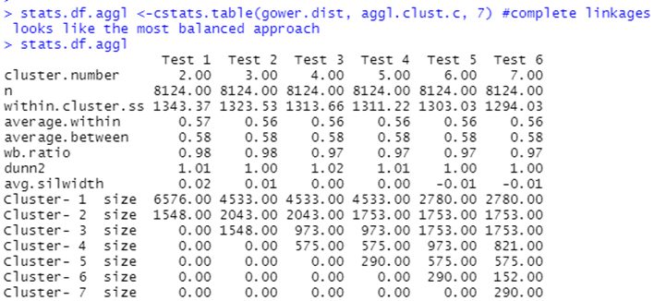

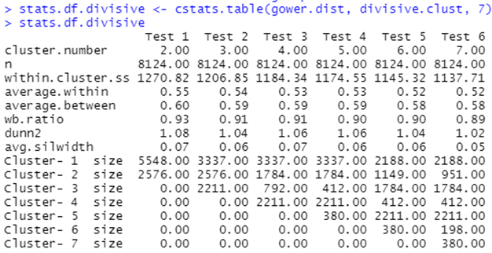

*Association Rule Mining*

Arules package in R is used to generate relationships between features within the processed mushrooms dataset. Additionally pre-processing for association rule mining included factorizing every categorical column representing a mushroom feature. A strong set of general rules was achieved through tuning the support, confidence, and maxlen parameters using the apriori algorithm for associative rule generation. A large set (98) of rules which encapsulates many of the features on the mushroom’s dataset, was generated to observe rules at large. The tuning for the apriori algorithm had parameters of support = 0.5, confidence = 0.9, maxlen = 5, and the top 10 sorted by decreasing lift are shown below.

*Large set of Association Rules (98)*

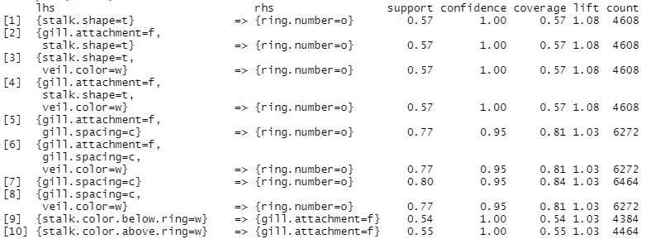

*Targeting Features with Association Rule Mining*

Through targeting class of “e” or “p” on both the left- and right-hand side of the rule, the following sets were generated. The tuning parameters were set to support = 0.30 , confidence = 0.90 , maxlen = 5 . The following rulesets show the top 10 ( if present ) for comparison.

***Target class=e on rhs***

***Target class=e on lhs***

***Target class=p on rhs***

***Target class=p on lhs***

*Decision Tree and Random Forest*

Decision Trees were made after first performing testing and training split sequencing of the original data. Every 4th index went into the test dataset., leaving 75 % in the training data ( about 6000 instances) . Decision Tree makes use of the factorized dataframe that was pre-processed prior. The output of the call is shown to the right with the corresponding confusion matrix from prediciton displayed directly below.

The fancyRpartplot call on the same decision tree Is shown below.

*Random Forest*

Given that random forest is an iteration of the Decision tree method, the same training and test data could be used. The ntree parmeter specifies the number of decision trees to use in the algorithm, with final number being set to ntree= 11 for 100% prediction accuracy.

**Results**

*Results of Hierarchical Clustering*

The graph shows how many levels are inside the categorical variables, and the result came up with nonsense. Since the categorical data is discrete, and the combination of the data is limited.

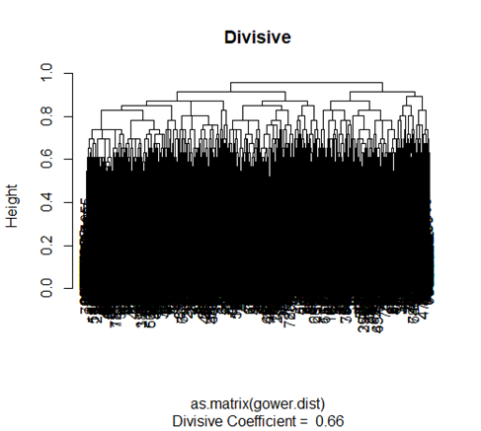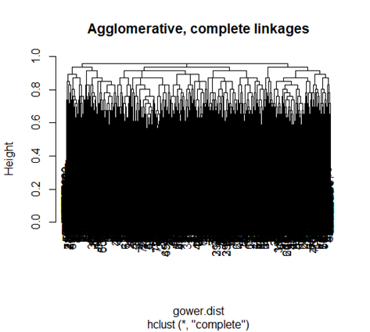

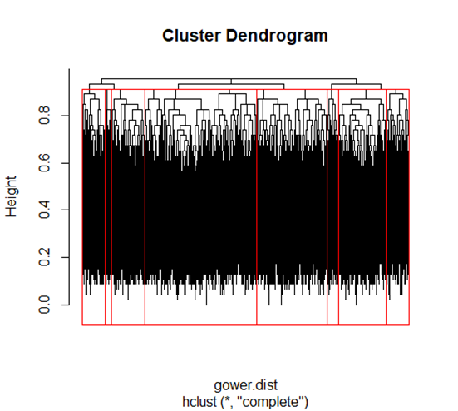

*Results of Association Rule Mining Large Set (98 rules)*

Generating this large set of rules was important for visualizing associations of features, however it would be confusing if a researcher did not know there were two distinct classes of mushrooms present in the dataset. Notice with the larger dataset, sorting by decreasing lift reveals weak lift in a set of rules targeted at all features in the dataset. It is likely that while there are overlap in some features between classes of mushroom, we are unable to tell because of the strength with which one feature is associated with another. The maxlen = 5 parameter setting did nothing to limit the output in this instance, because there are usually only two features on the left-hand side of the rules. While this information does nothing to predict edible class, it is informative of the strengths between features in mushrooms. Below is a visualization of the set of top 10 rules association found when using parameters support = 0.30, confidence = 0.90, maxlen = 5 .

*Results of Targeting Features with Association Rule Mining*

In targeting features on the left- and right-hand side, it was most evident that mushrooms of a particular class were associated with certain features. Additionally, this analysis revealed that some features are globally associated with mushrooms of either class. Identical tuning parameters of support = 0.30, confidence = 0.90, maxlen = 5 were used when focusing on the left-hand side. While these generated disproportionate sizes of rules overall (class=’e’, 88 rules) vs (class=’p’, 18 rules), notice the support for the rules of strongest lift are all barely over support = 0.30. This was discovered during the tuning of the rules, and in looking at the features present in the top 10 sets allows us to understand what features are most important for mushrooms of either class, or which are important for neither. The visualizations for the top 10 rules of either class on targeted on the rhs are on the next page. These are features that associate with this class, and not the class’s association with features which is shown in the next section.

***Visualization of top 10 rules Targeting class=e on rhs***

***Visualization of top 10 rules Targeting class=p on rhs***

*Features Associated with Class ‘e’ or ‘p’*

The node diagrams above show features linked via strength through distance, notice first that gill.attachment=f, veil.color=w, and ring.attachment=o are universal in both sets of class predicting rules. These associations were also revealed while generating the large rule set without targeting. It’s important to remember the data was from two sets of closely linked species, each having their own poisonous and non- members. Therefore, these features can be recognized as strongly correlative because of the general morphology of the species present. If this study was applied to mushrooms universally, there would be differ feature association results based on the species contained within the dataset analyzed.

*Targeting class on LHS ‘e’ or p*

Class ‘e’ and ‘p’ when targeted on LHS generated very small rulesets. This how the class alone as a feature can associate to other features (instead of multiple features associating to just the class). Mushrooms had a few features that were strongly associated with either class ‘e’ or ‘p’, which is shown by the incredibly small rulesets generated on the LHS. Some of these features appeared on both the left- and right-hand side of the association rule mining. Essentially, at targeting class on LHS reiterates some of what was seen in the general rule construction with no targeting. The same features (ring.number=o, gill.attachment=f, veil.color=w) are present in either, and were in the larger set of rules. These are clearly strong features that are associated with the genera *Agaricus* and *Lepiota*. Since species was not present in the original dataset, its not possible to move beyond generally saying that these rules apply to these two genera alone. What further solidifies these rules as being associated with these genera are the empty LHS in either set below. The coverage for these is 1.00, meaning these features were present enough they could be associated with almost anything else.

***Targeting ‘e’ on LHS***

***Targeting ‘p’ on LHS***

*Targeting class on RHS ‘e’ or p*

Targeting on the RHS revealed slightly longer, more detailed groupings of features that predicted edibility. The general features are still present, but new features surpass their strength of association, as the maxlen = 5 parameter has allowed for up to 5 features to associated with either class. The top 10 rules all have one defining characteristic for either class. Class = ‘e’ is highly predicted from odor=n. Class = ‘p’ displays a predicted association from bruises=f. The lift for these rules is close to 2, yet coverage never reaches about 50%. There is still some variation within the poisonous and edible mushrooms, otherwise we would see more proportional associations on these rulesets. These were the rulesets that were used to generate the visualizations above that denote ‘e’ or ‘p’. The visualizations communicate the similarities and differences between the features and classes much more clearly than the rules. These rules allow us to dig into measurement of features and associations more. That really isn’t useful without having the actual species of the mushroom present, because at this level we don’t have an completely advisable situation for the real world based on our results.

***Class = ‘e’ on RHS***

***Class = ‘p’ on RHS***

*Results of Decision Tree*

The results of utilizing decision tree classification were incredibly effective. As shown in the visualization below. As the nodes in the tree suggest the most significant dividing factors inA picture containing text, clock

Cross referencing of these features can be done with other models to reinforce their significance. Additionally, this visualization includes both numbers of the decision split in each node. In reviewing the root node, 52% of the instances had odor = a, l, n. In the Association Rules mining section, the odor=n feature was very closely linked with a class=e instance, and that seems to be a strong enough influence to separate many of the mushrooms by class. Mushrooms without the those few odors, were poisonous mushrooms seen in blue, however a few did. The purity can be seen by .00 and 1.00 with the number of instances in this node representing 47% of all instances. Looking back to the root node, with 48% of instances in the original data not being classed as ‘e’, this model was able to classify almost 99% of the poisonous mushrooms within the first decision. The next and final decision of the tree went on spore.print.color = b,h,k,n,o,u,w,y. This node was not pure to begin with, as it had 97 % with class of e, and 3% class p. This decision only was able to purely split off some of the remaining 3% class p mushrooms, but not all. Seen by the final decision nodes after the 2nd decision, there were 1% of the poisonous mushrooms that still were classified as edible mushrooms.

While this is incredibly high accuracy, it’s not perfect. The significance of mistaking a poisonous mushroom for an edible one could be very grave. Given this dataset was hypothetical examples of only two species of mushrooms, this level of accuracy would only decrease as the prediction is generalized to more species of mushrooms. These results also are not informing one species of mushroom or another, or any tangible actions that a forager can do, a spore print cannot be taken in the field as it takes time to imprint.

**Conclusions**

The vary techniques employed demonstrated discovery in machine learning with categorical data. Increasing the variance by deploying this model to new data would likely not yield accurate results. The approach demonstrated should be replicated with increased data, through which an expected efficiency drop-off many appear with a larger, more diverse dataset of mushroom examples. If through expanding research within the field to generate this large dataset proves to create this problem. It is at that point that a larger general cluster analysis could be performed to perhaps see if family and order could be classified. If a tiered approach was leveraged, it may be possible to achieve a larger version of the classification of poisonous or edible on mushrooms.

Our research highlighted only a few (albeit unknown) species of mushrooms, truly more work must be done to accurately library specimens in digital form, which would have issues in agreeing on what is current. It is hard to have real time insight on the current facts in the scientific community, as theories must be continually built and tested to generate evidentiary facts. What has been proposed is the beginning of a thread, which if pulled may continue to reveal aspects of the fungi kingdom that science currently overlooks or underestimates. It would be very interesting to first compare this hypothetical data with real world collected specimens of the same genera, with species names. Moving to includes species names as a factor of prediction is adding more complexity, but simply warranted from the need to understand the variations within and across genera. There must be much effort put for to integrate records of specimens into a digital format. That can then be utilized more efficiently to test machine learning across mushroom species. In that, it would take a considerable amount of effort to integrate universal categorizations for all “mushroom forming” fungi, and even then, there are many blurred lines in the kingdom (such as slime molds, ergot fungus, and yeast). Would it be possible to capture a majority if not all members of the fungi kingdom in terms of their features? It may be so that in doing that, too much complexity will have been added to understand unique differences from noise in the population in mushrooms. Tuning must be done and different approaches must be taken in trying to relate between species, genera, and families,

In addition to specimen knowledge, the many cultures must be studied in which species of mushrooms are found. Preserving ethnic groups and cultures across the globe is an intrinsic aspect to the work. The things that these cultures used mushrooms for may reveal aspects of their chemistry or history that inform the nature of the ecosystem. The Traditional knowledge stems from generations of experience living in a particular ecosystem, and without its researchers may take much longer to find enough specimens safely. There are so many aspects of culture, ecology, and medicine, that there are many unknowns to be unearthed regarding mushrooms.

**References**

**The** **mushroom** **dataset**

<https://www.kaggle.com/datasets/uciml/mushroom-classification?resource=download>

FoodPrint. (2019, December 9). *Mushrooms*. FoodPrint. Retrieved September 5, 2022, from https://foodprint.org/real-food/mushrooms/

Haro-Luna, M. X., Ruan-Soto, F., & Guzmán-Dávalos, L. (2019, September 16). *Traditional knowledge, uses, and perceptions of mushrooms among the WIXARITARI and mestizos of Villa Guerrero, Jalisco, Mexico - Ima fungus*. BioMed Central. Retrieved September 18, 2022, from https://imafungus.biomedcentral.com/articles/10.1186/s43008-019-0014-6

Handwerk, B. (2021, February 2). *An evolutionary timeline of homo sapiens*. Smithsonian.com. Retrieved September 5, 2022, from https://www.smithsonianmag.com/science-nature/essential-timeline-understanding-evolution-homo-sapiens-180976807/

Heads, S. W., Miller, A. N., Crane, J. L., Thomas, M. J., Ruffatto, D. M., Methven, A. S., Raudabaugh, D. B., & Wang, Y. (2017, June 7). *The oldest fossil mushroom*. PLOS ONE. Retrieved September 17, 2022, from <https://journals.plos.org/plosone/article?id=10.1371%2Fjournal.pone.0178327>

Reusova, A. (2019, March 26). *Hierarchical clustering on categorical data in R*. Medium. Retrieved September 18, 2022, from https://towardsdatascience.com/hierarchical-clustering-on-categorical-data-in-r-a27e578f2995

The Santa Cruz Mycoflora Project. (n.d.). *Genus: Lepiota*. Lepiota Mushroom Species. Retrieved September 18, 2022, from https://scmycoflora.org/genera/lepiota/lepiota-species.php

Sitotaw, R., Lulekal, E., & Abate, D. (2020, March 4). *Ethnomycological study of edible and medicinal mushrooms in Menge District, Asossa Zone, Benshangul Gumuz Region, Ethiopia - Journal of Ethnobiology and ethnomedicine*. BioMed Central. Retrieved September 17, 2022, from https://ethnobiomed.biomedcentral.com/articles/10.1186/s13002-020-00361-9

Skarbo, S. (2014, September 14.). *Whale hunting and Magic Mushroom people of 2,000-year-old Eurasia's northernmost art gallery*. RSS. Retrieved September 17, 2022, from https://siberiantimes.com/other/others/news/whale-hunting-and-magic-mushroom-people-of-2000-year-old-eurasias-northernmost-art-gallery/

TERI WRC. (n.d.). *Agaricus sp.: Mushrooms: TERI WRC: Digital Library*. Nutrition Security. Retrieved September 18, 2022, from http://wildedibles.teriin.org/index.php?album=Mushrooms%2FAgaricus-sp

Valverde, M. E., Hernández-Pérez, T., & Paredes-López, O. (2015). *Edible mushrooms: Improving human health and promoting Quality Life*. International journal of microbiology. Retrieved September 5, 2022, from https://www.ncbi.nlm.nih.gov/pmc/articles/PMC4320875/#:~:text=Mushrooms%20have%20been%20consumed%20since,have%20been%20part%20of%20the

**APPENDIX A**

*Levels of the Features*

$class

[1] "e" "p"

(classes: edible=e, poisonous=p)

$cap.shape

[1] "b" "c" "f" "k" "s" "x"

bell=b,conical=c,convex=x,flat=f, knobbed=k,sunken=s

$cap.surface

[1] "f" "g" "s" "y"

fibrous=f,grooves=g,scaly=y,smooth=s

$cap.color

[1] "b" "c" "e" "g" "n" "p" "r" "u" "w" "y"

brown=n,buff=b,cinnamon=c,gray=g,green=r,pink=p,purple=u,red=e,white=w,yellow=y

$bruises

[1] "f" "t"

bruises=t,no=f

$odor

[1] "a" "c" "f" "l" "m" "n" "p" "s" "y"

almond=a,anise=l,creosote=c,fishy=y,foul=f,musty=m,none=n,pungent=p,spicy=s

$gill.attachment

[1] "a" "f"

attached=a,descending=d,free=f,notched=n

$gill.spacing

[1] "c" "w"

close=c,crowded=w,distant=d

$gill.size

[1] "b" "n"

broad=b,narrow=n

$gill.color

[1] "b" "e" "g" "h" "k" "n" "o" "p" "r" "u" "w" "y"

black=k,brown=n,buff=b,chocolate=h,gray=g, green=r,orange=o,pink=p,purple=u,red=e,white=w,yellow=y

$stalk.shape

[1] "e" "t"

enlarging=e,tapering=t

$stalk.root

[1] "?" "b" "c" "e" "r"

bulbous=b,club=c,cup=u,equal=e,rhizomorphs=z,rooted=r,missing=?

$stalk.surface.above.ring

[1] "f" "k" "s" "y"

fibrous=f,scaly=y,silky=k,smooth=s

$stalk.surface.below.ring

[1] "f" "k" "s" "y"

fibrous=f,scaly=y,silky=k,smooth=s

$stalk.color.above.ring

[1] "b" "c" "e" "g" "n" "o" "p" "w" "y"

brown=n,buff=b,cinnamon=c,gray=g,orange=o,pink=p,red=e,white=w,yellow=y

$stalk.color.below.ring

[1] "b" "c" "e" "g" "n" "o" "p" "w" "y"

brown=n,buff=b,cinnamon=c,gray=g,orange=o,pink=p,red=e,white=w,yellow=y

$veil.type

[1] "p" “u”

partial=p,universal=u

$veil.color

[1] "n" "o" "w" "y"

brown=n,orange=o,white=w,yellow=y

$ring.number

[1] "n" "o" "t"

none=n,one=o,two=t

$ring.type

[1] "e" "f" "l" "n" "p" “c”, “s”, “z”

cobwebby=c,evanescent=e,flaring=f,large=l,none=n,pendant=p,sheathing=s,zone=z

$spore.print.color

[1] "b" "h" "k" "n" "o" "r" "u" "w" "y"

black=k,brown=n,buff=b,chocolate=h,green=r,orange=o,purple=u,white=w,yellow=y

$population

[1] "a" "c" "n" "s" "v" "y"

abundant=a,clustered=c,numerous=n,scattered=s,several=v,solitary=y

$habitat

[1] "d" "g" "l" "m" "p" "u" "w"

grasses=g,leaves=l,meadows=m,paths=p,urban=u,waste=w,woods=d